sportyshoes.com

Software Requirements Specification

1.0

11-05-2023

Roseline Ayitey

Full Stack developer

Prepared for

Simplilearn FSD Programme

## Introduction

Sportyshoes.com is an ecommerce shop built for Sporty Shoes, a company that manufactures and sells sports shoes. The system keeps track of its products, users, and reports. It has a back-office application with a single administrator login. This document provides details on product’s capabilities, appearance, user interactions.

## Purpose

The purpose of this document is to capture the product details below.

* Product’s capabilities, appearance, and user interactions
* Project and developer details
* Sprints planned and the tasks achieved in them
* Core concepts used in the project
* Links to the GitHub repository to verify the project completion

## Product Capabilities

The product is a backend administrative portal for an ecommerce shop that provides the options to administrators to perform the below activities

* Login to manage the website
* Change password
* Add products to the inventory
* Update product details
* Categorize products
* Delete products
* Browse users
* Search for users
* See purchase reports filtered by date and category

### User Interfaces

**GUI**  
As this is a web application, user interaction is via GUI.

**APPLICATION FLOW**

Step1 - Application starts by displaying the login page for the administrator to login in

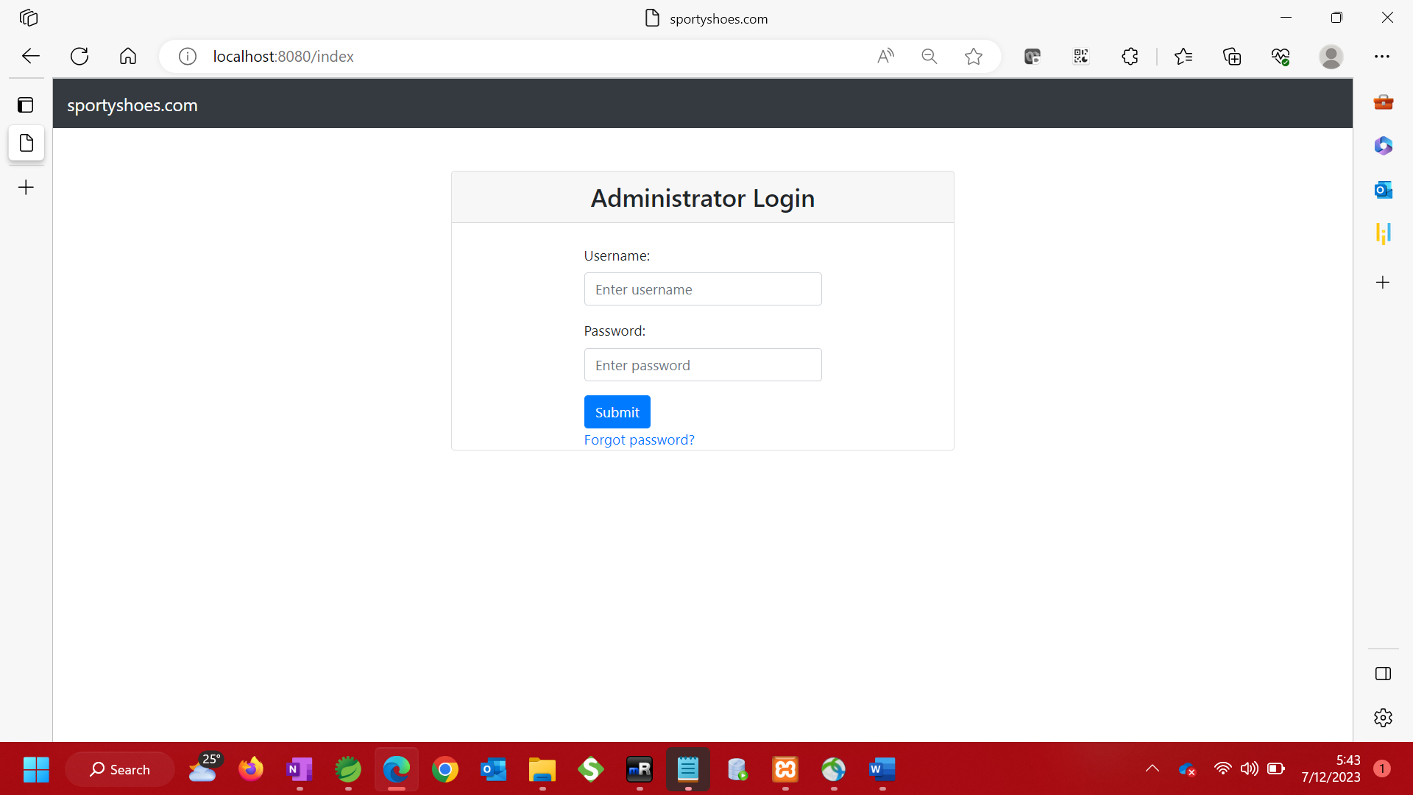

Step 2: Take user input and check if credentials are correct. Stay on login page and show error message if credentials are not correct.

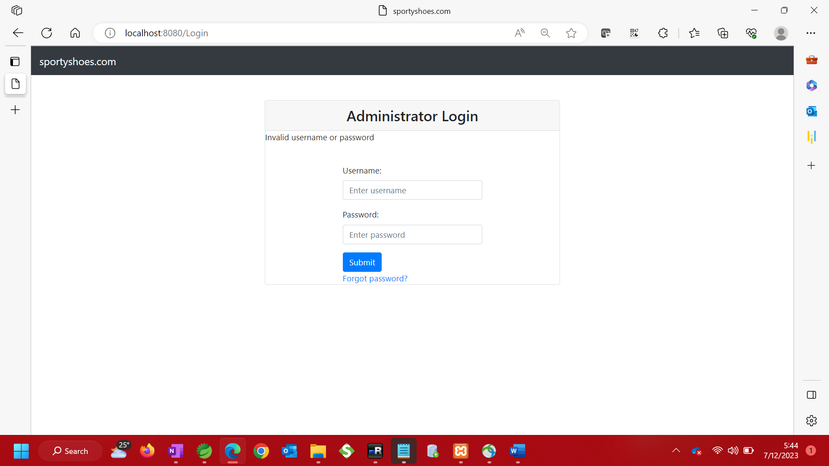

Step3. Display dashboard page with menu items if credentials are correct

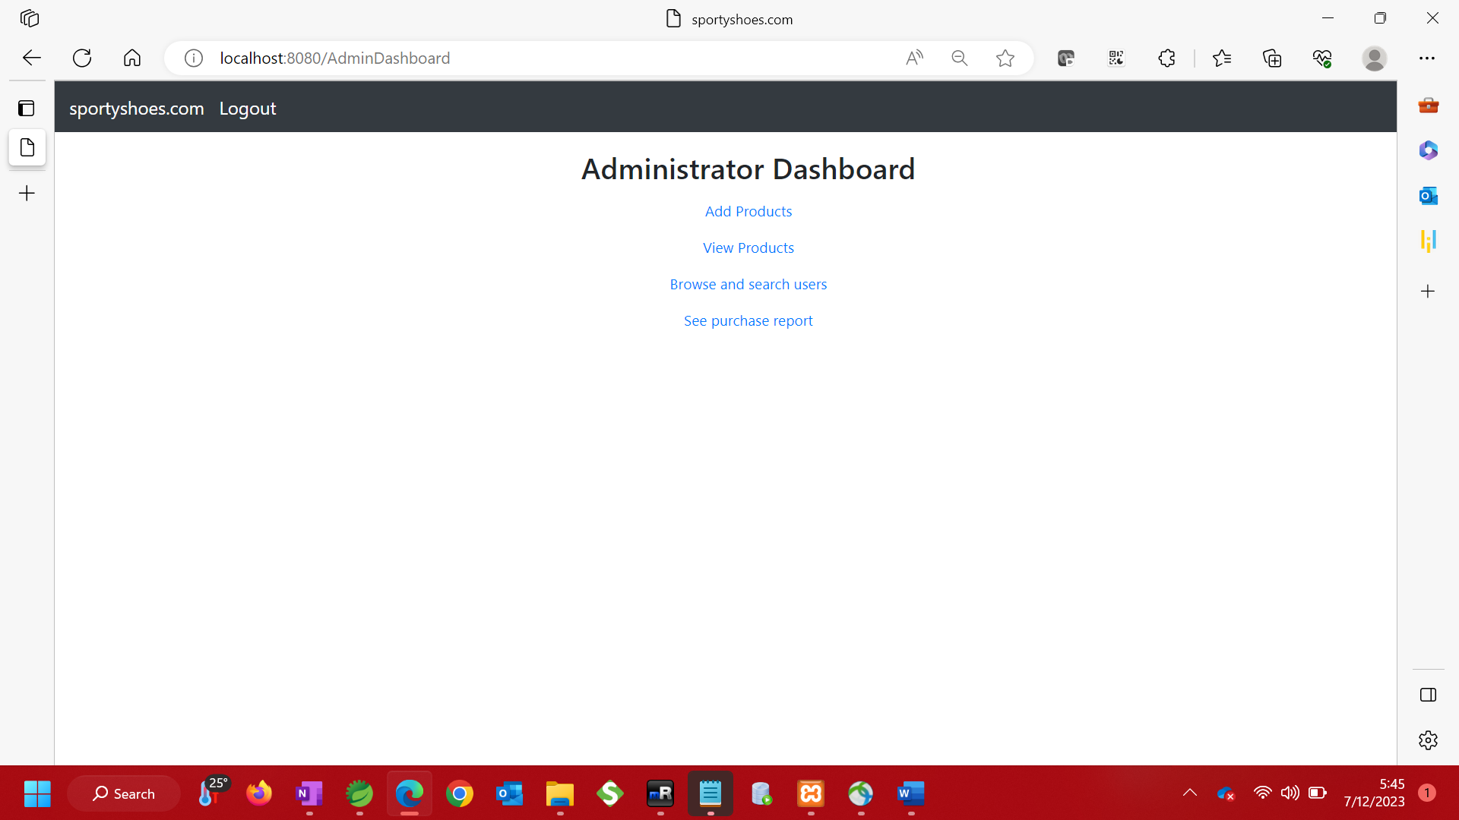

Step 4 – Select an item from the menu options

1. Add Products to inventory

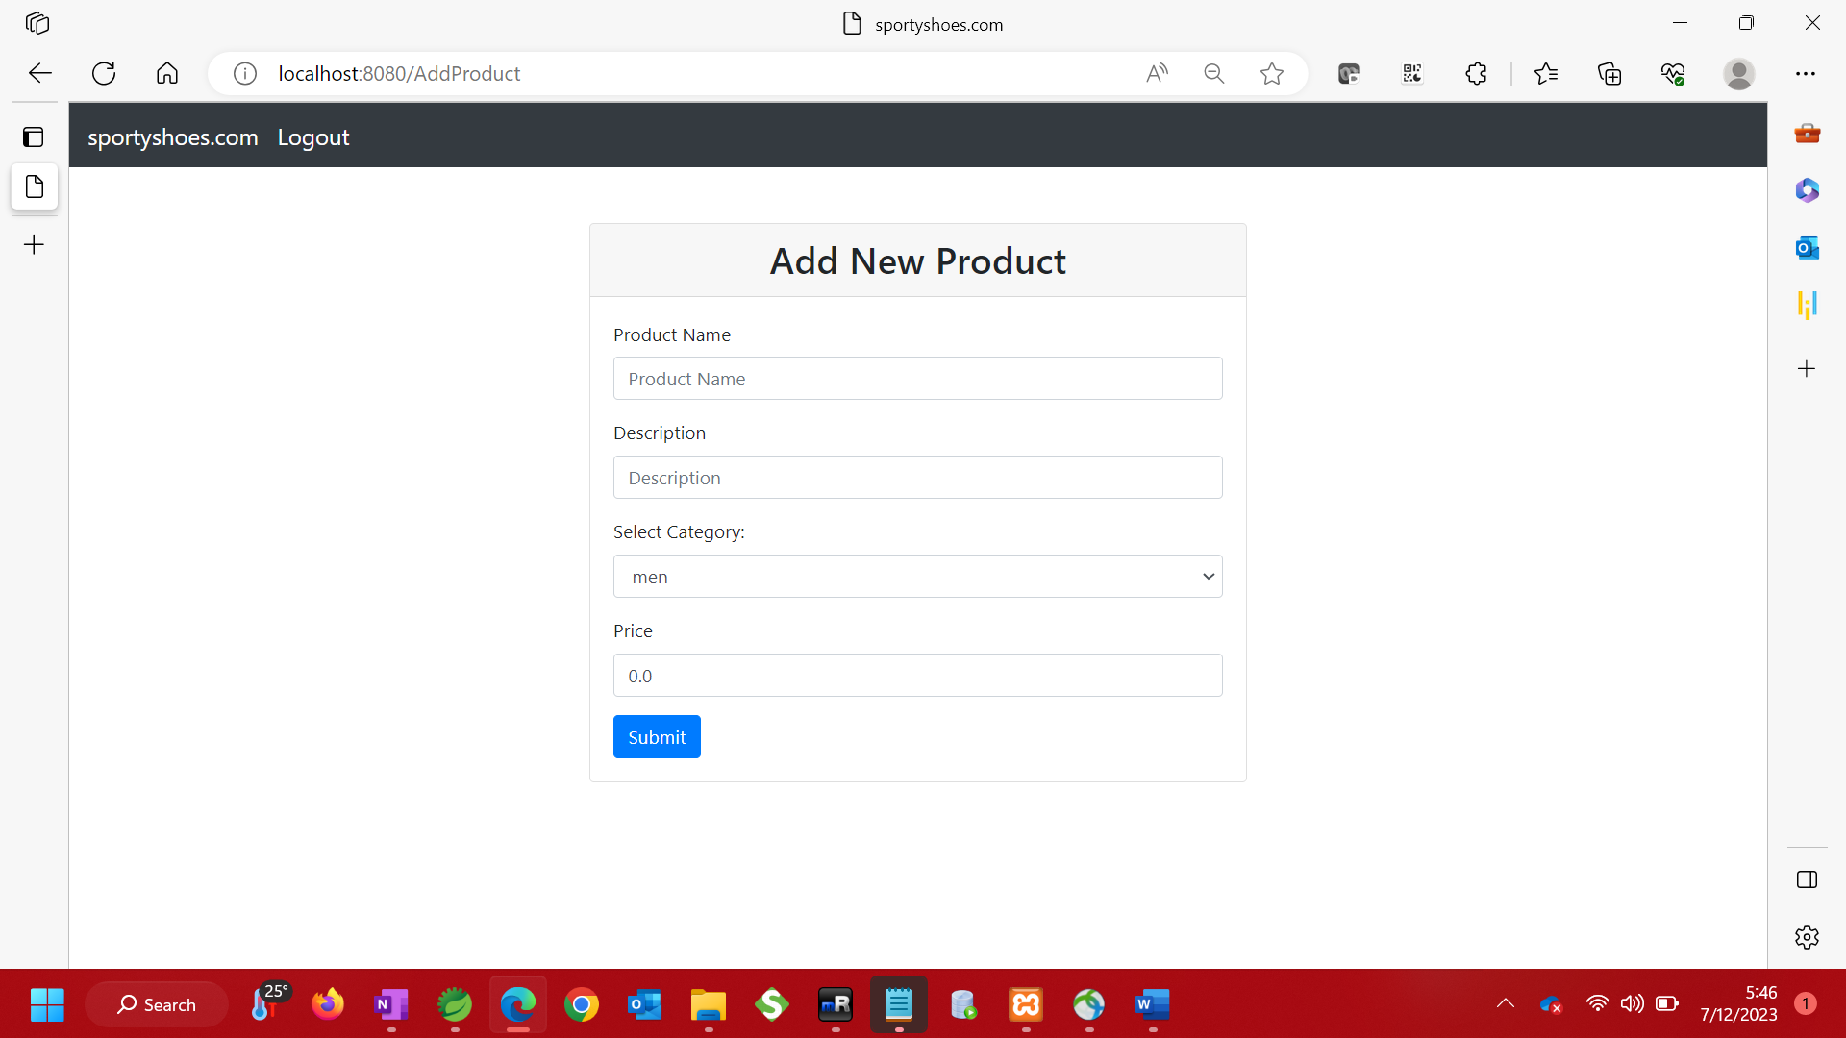

i. Validate input to ensure field is not empty on submission. If input is empty, display message.

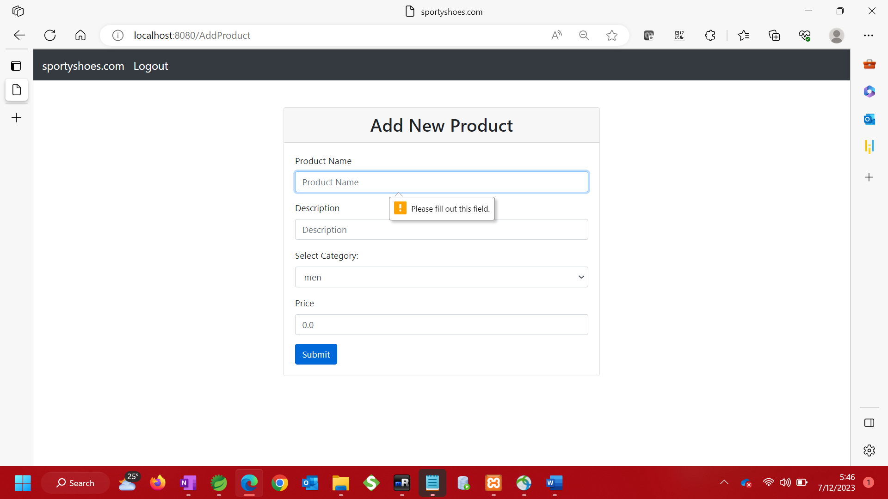

ii. If input is not empty, submit to database and redirect to view products page to view the new product added

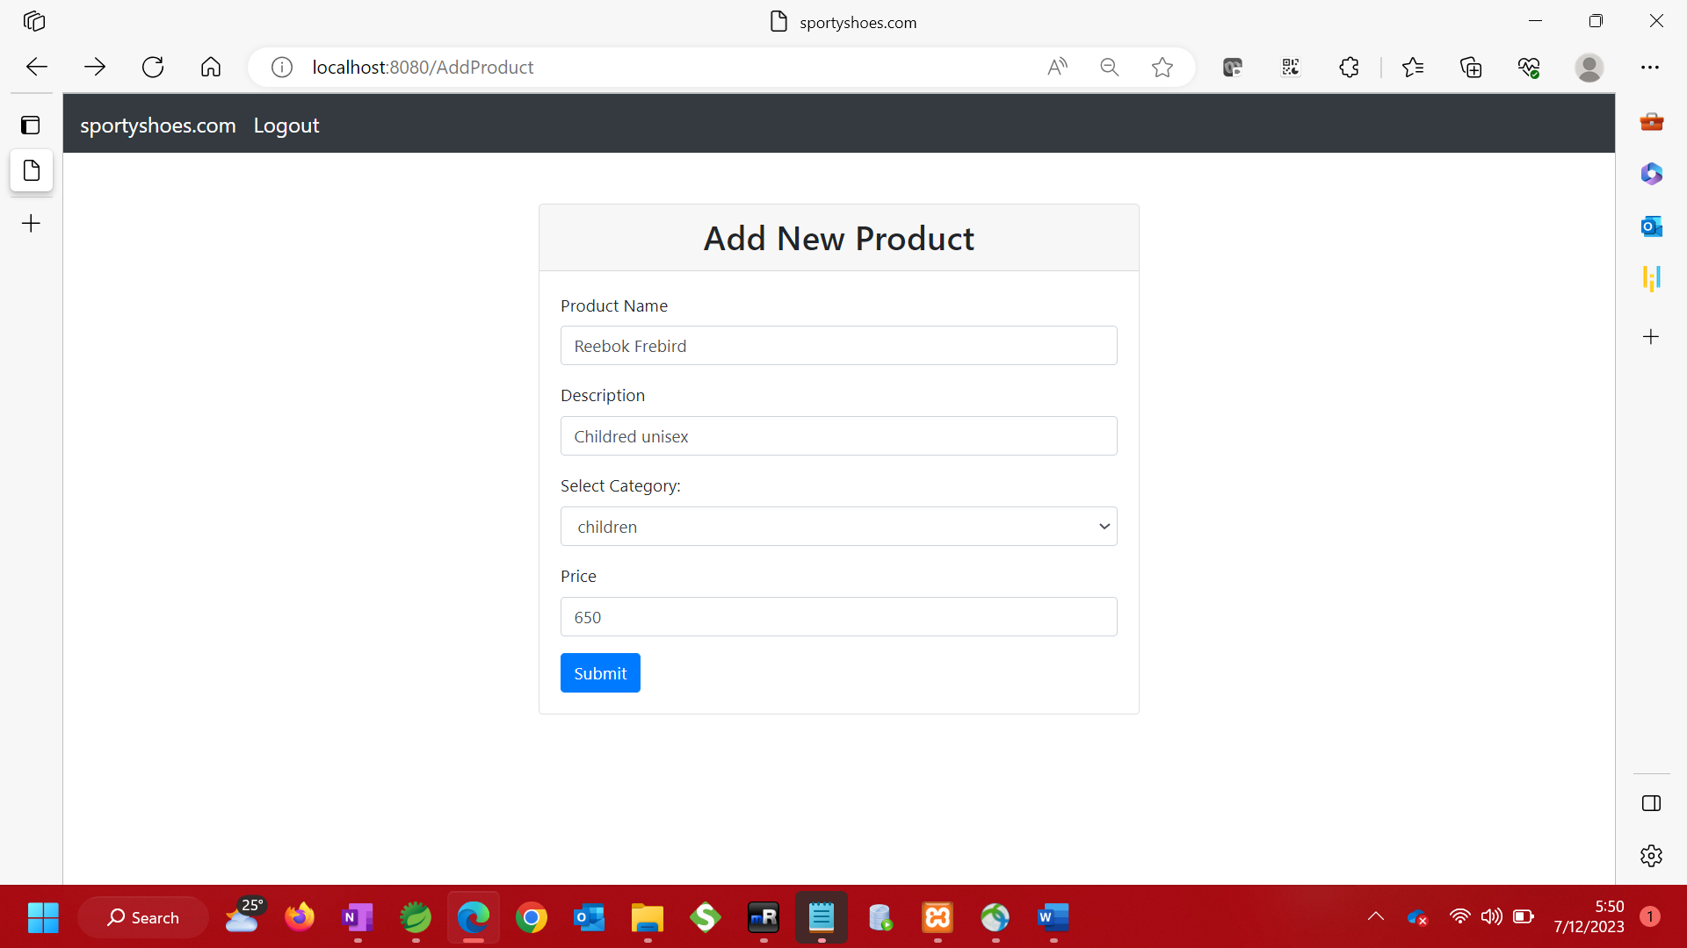

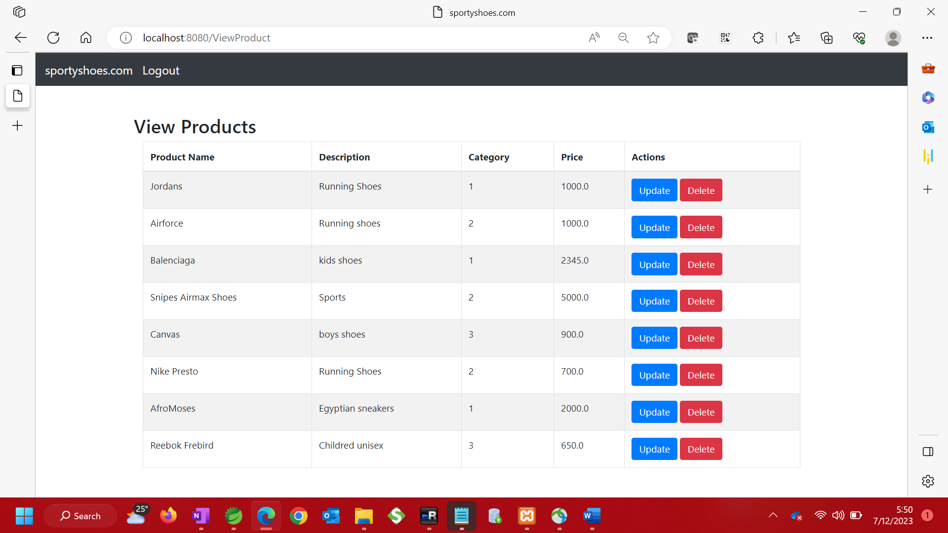

1. Update Product Details

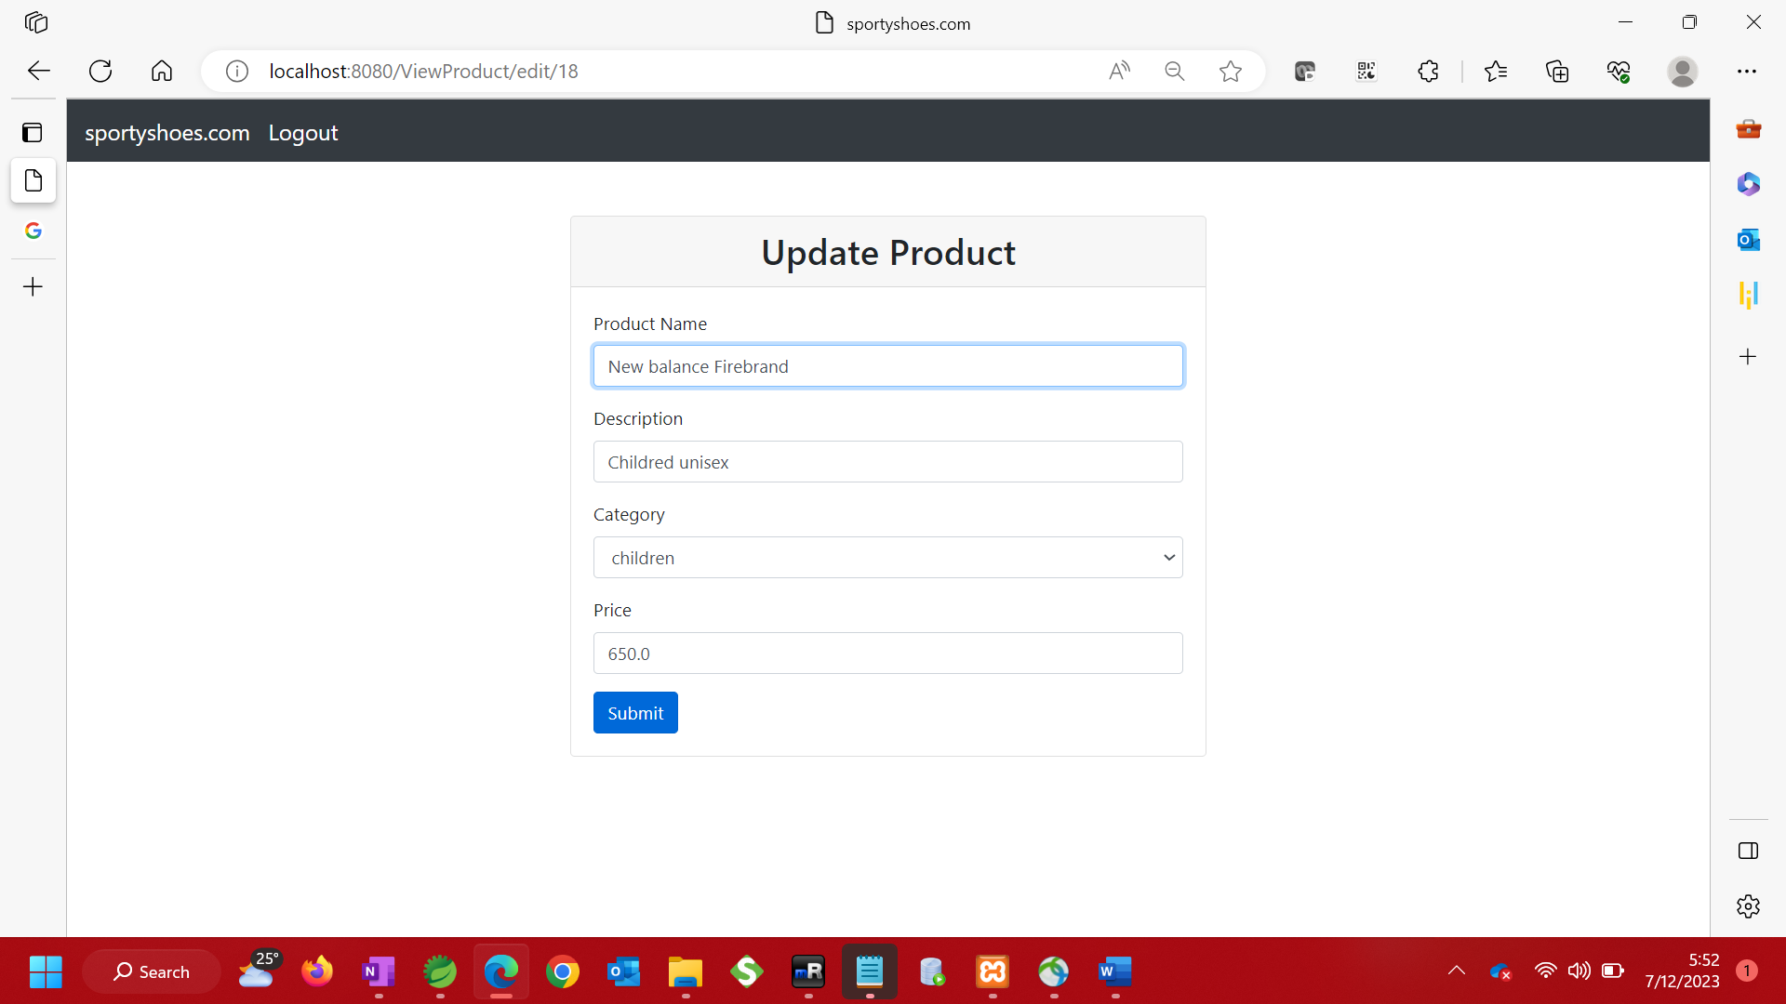

Update Category

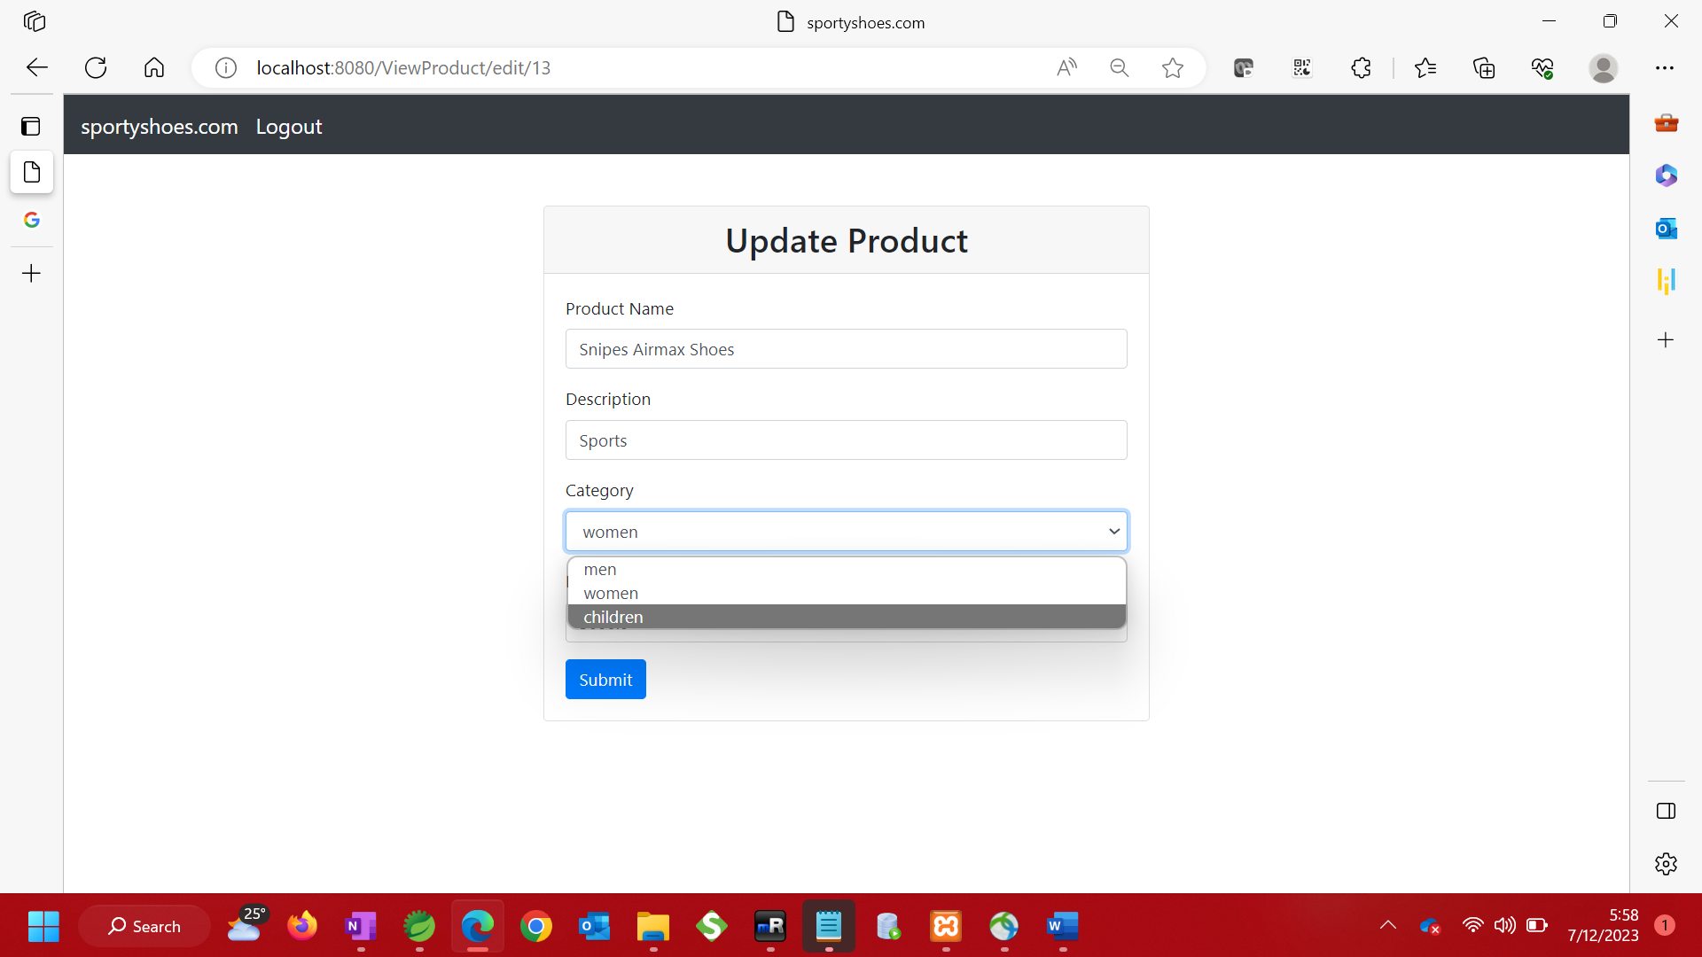

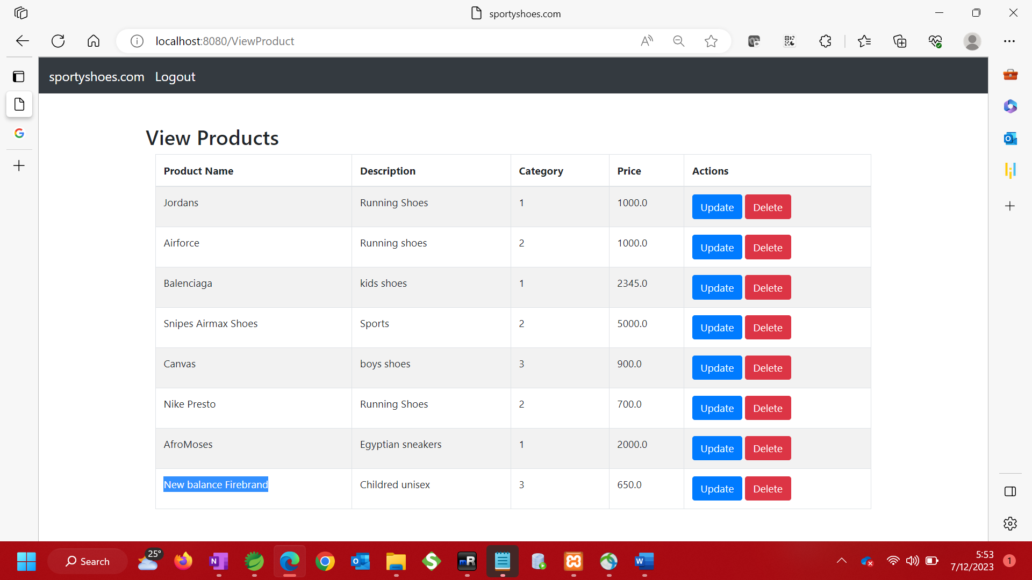

View updated category

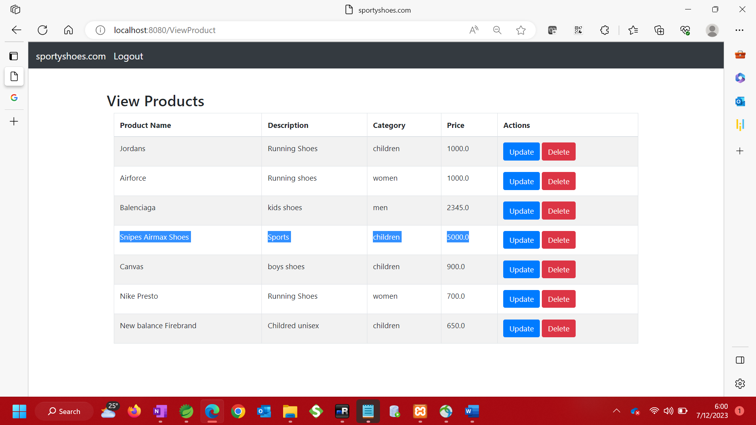

1. Delete Product

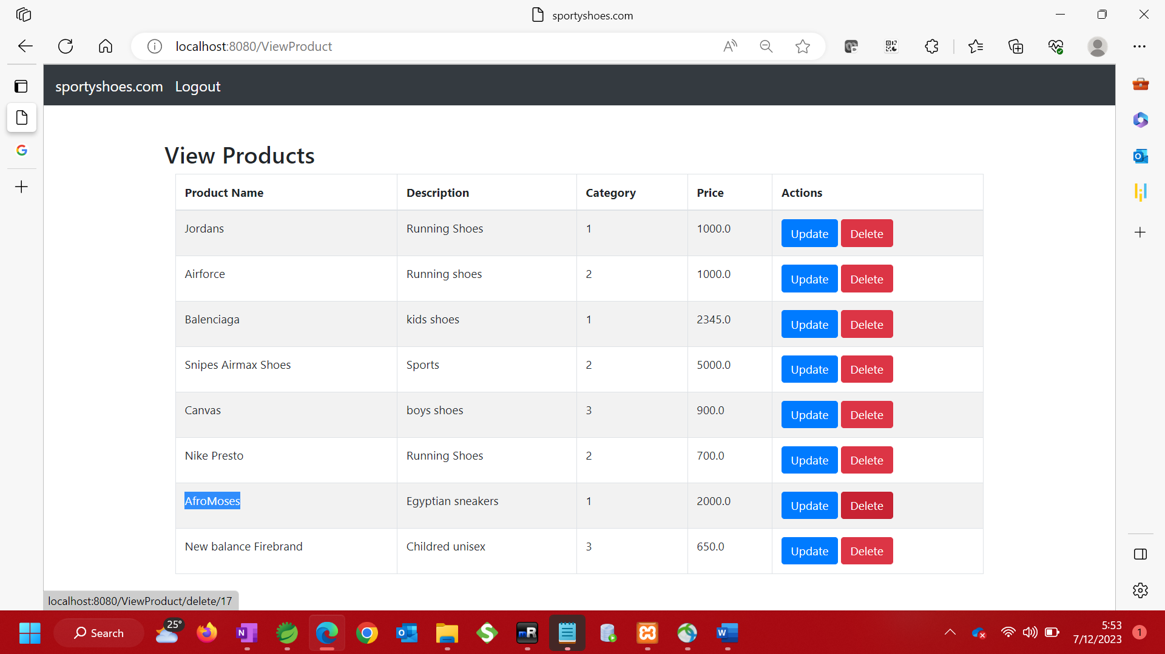

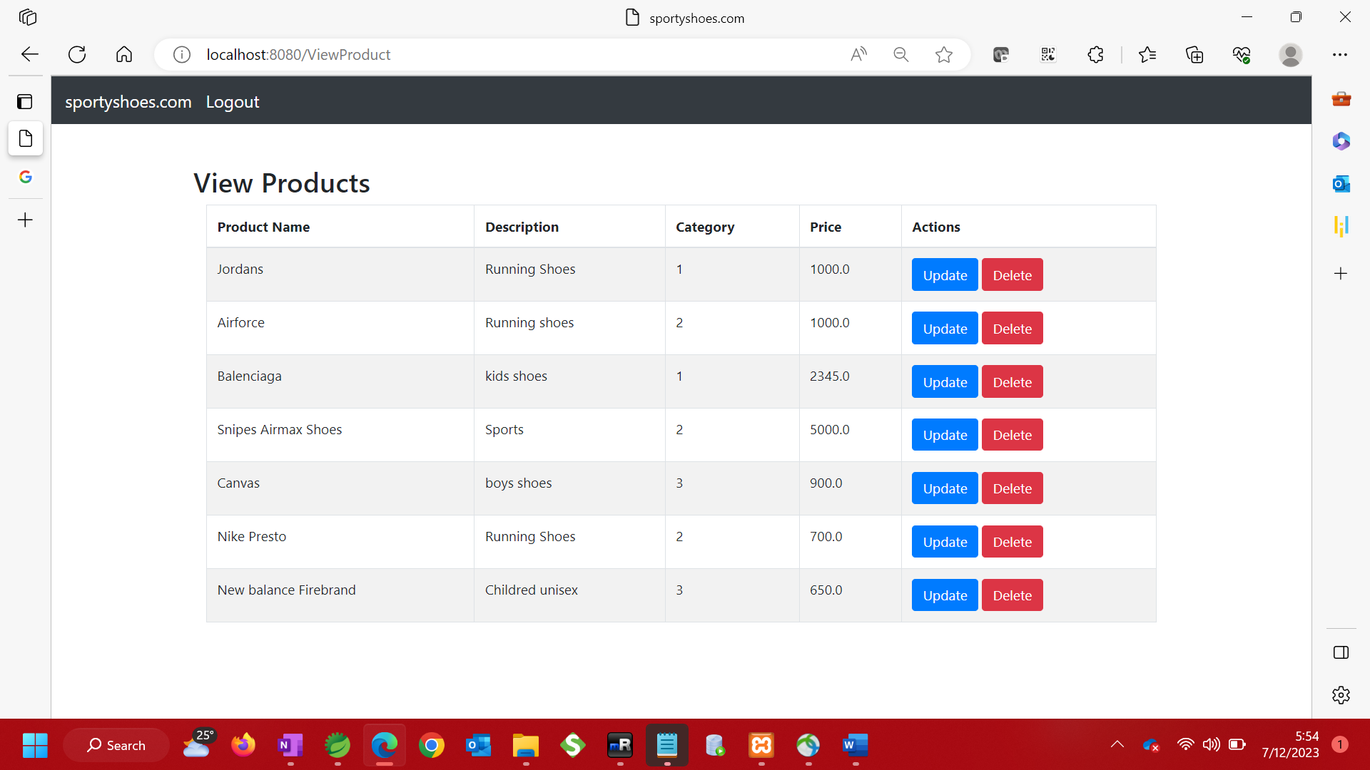

1. Browse users – Admin is able to view all users

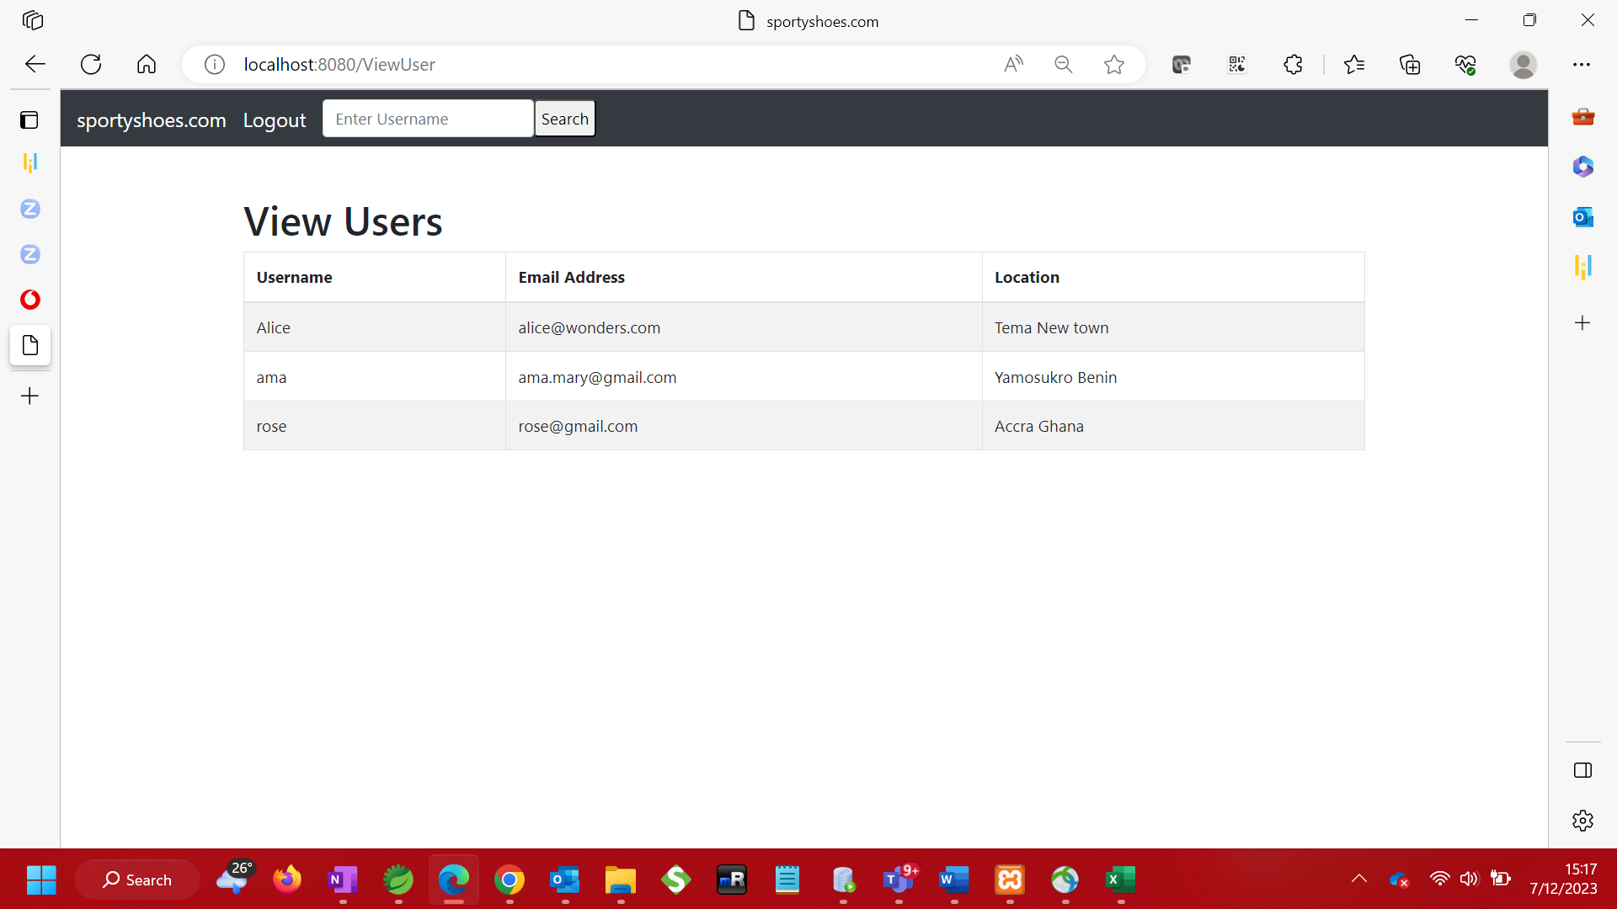

1. Search by username

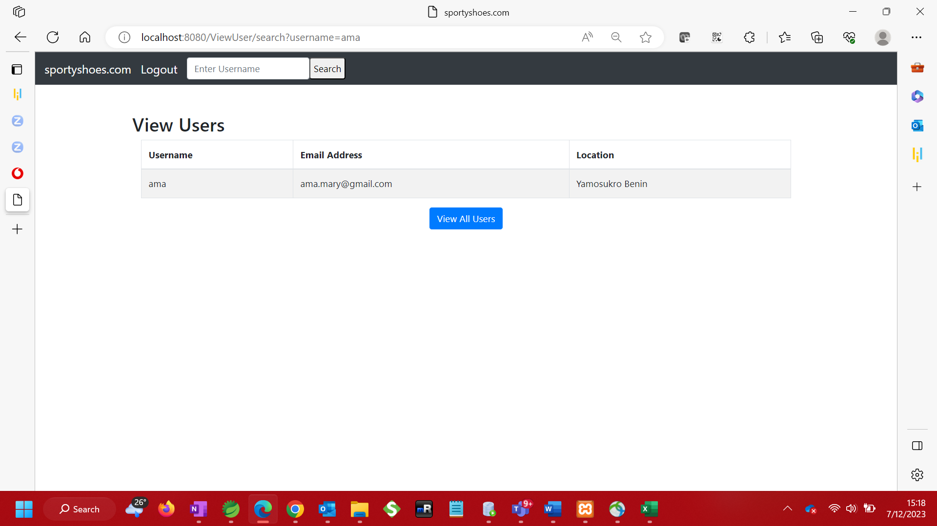

1. View purchase report

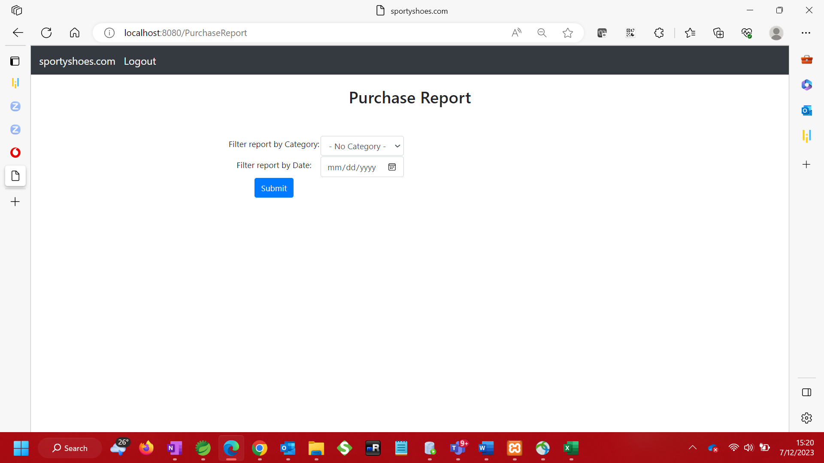

Filter purchase report by Date or by Category

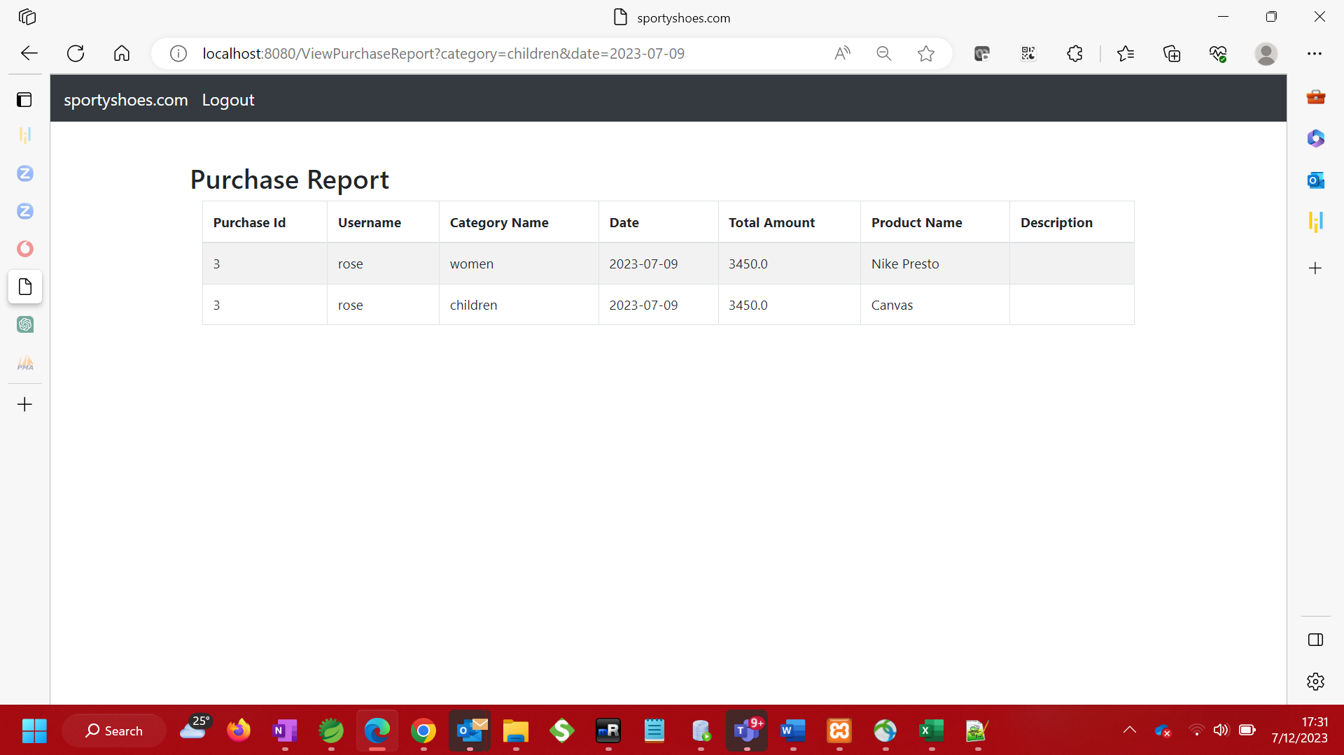

**SPRINT PLANNING**

The functionalities were converted to below user stories with story points assigned and placed in the product backlog. SS – (Sporty Shoes)

|  |  |  |
| --- | --- | --- |
| Story ID | User Story (Product backlog) | Story points |
| SS01 | As an administrator, want to login to manage inventory | 1 |
| SS02 | As an administrator, I want to add products to the inventory | 5 |
| SS03 | As an administrator, I want to update products | 5 |
| SS04 | As an administrator, I want to delete products | 5 |
| SS05 | As an administrator, I want to view users who have signed up | 3 |
| SS06 | As an administrator, I want to search for specific users | 5 |
| SS07 | As an administrator, I want to view items that have been purchased on the website in a report | 8 |
| SS08 | As an administrator, I want to filter the purchase report by category or date | 13 |
| SS09 | As an administrator, I want to logout when I’m done with my operations | 1 |

**The application was completed in 3 sprints with breakdown below.**

Sprint 1 || Stories - SS01, SS02, SS03|| Total points – 16

Sprint 2 || Stories SS04, SS05, SS06|| Total points – 16

Sprint 3 || Stories SS08, SS09 || Total points – 14

**CORE CONCEPTS AND ALGORITHYMS USED**

* Thymeleaf
* Java Springboot
* MVC
* JDBC
* JPA
* HTML
* CSS

Link to the GitHub repository

https://github.com/roselinemills/SportyShoes

**CONCLUSION**

The project is designed to be intuitive, easy to use and deliver high-end quality experience to the client.